Brantford Church Hockey League

69-79 Market Street South, Brantford, Ontario, N3S 2E4

Re: Volunteer Letter – Request for Criminal Records Check including the
Vulnerable Sector Screening (PVSC)

To: Police Services,

This will serve as notice that __________________________________ will be a volunteer with Brantford Church Hockey League (BCHL) for the 2018/2019 season.

Volunteer Position:
□ Coach □ Trainer □ Manager □ Assistant Coach

□ Other______________________________________
Since certain aspects of our organization deals with vulnerable person, children ages 4-18, kindly complete a:

Police Vulnerable Sector Check (PVSC)

I, George Ziotek as President Brantford Church Hockey League (BCHL) certify that the disclosure of information is required by BCHL because it is related to a bona fide occupational or volunteer position and is required for BCHL to assess the applicant’s suitability for the position. BCHL has explained to the applicant how the responsibilities of the position related to the request and has extended a conditional offer for the position to the applicant.

Respectfully Yours,
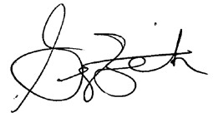
______________________________
George Ziotek
BCHL President

